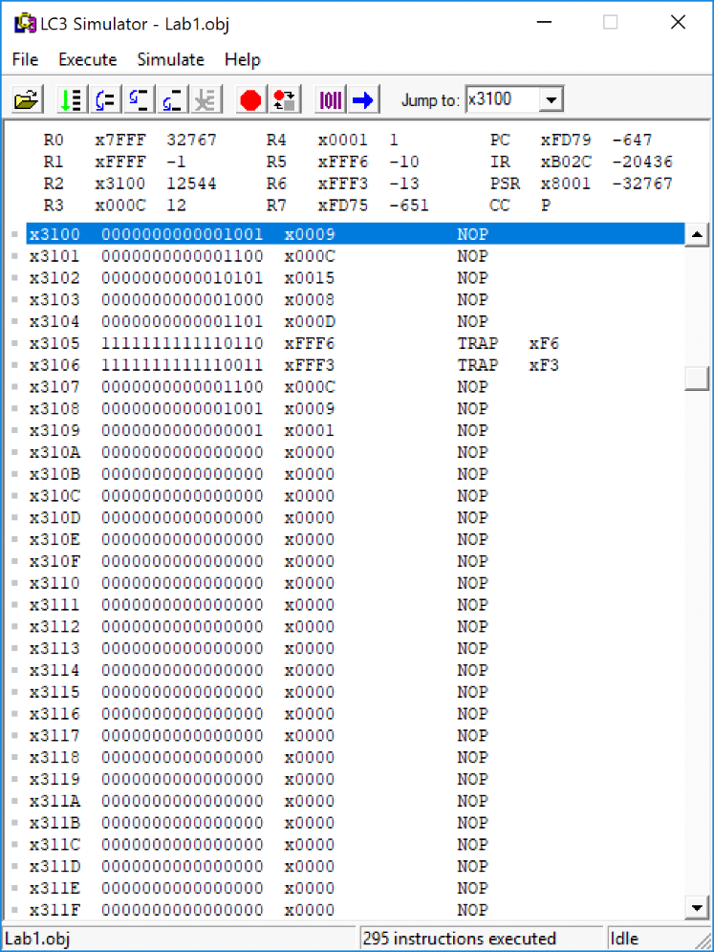
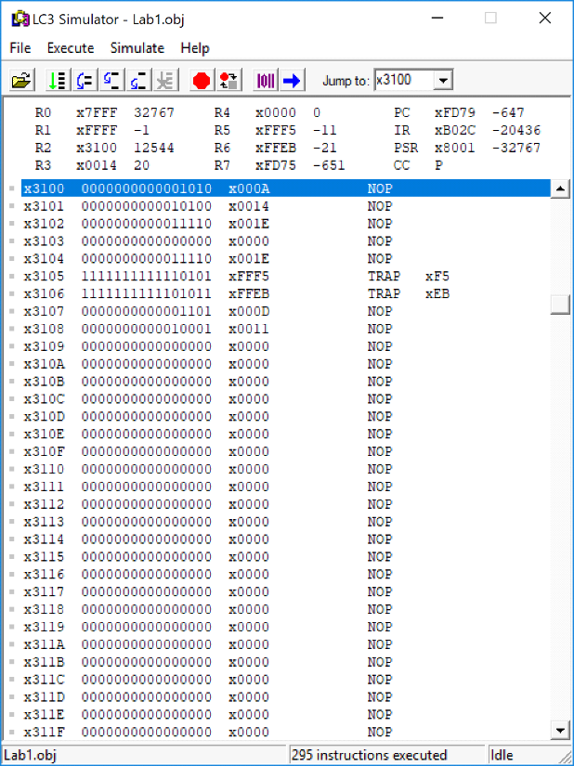
Hector Diaz Flores
004854001

Lab 1 Proof

(X,Y) Pair (9,12)

(X,Y) Pair (10,20)

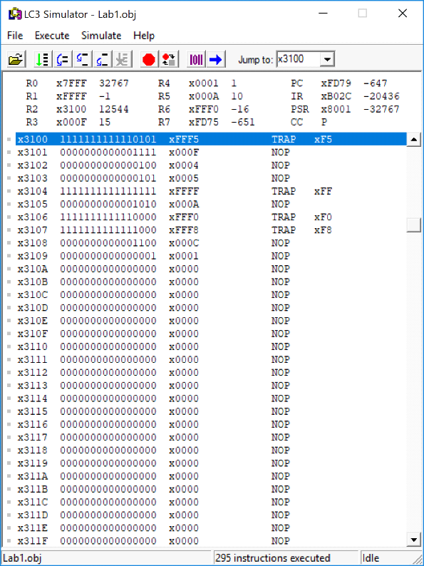
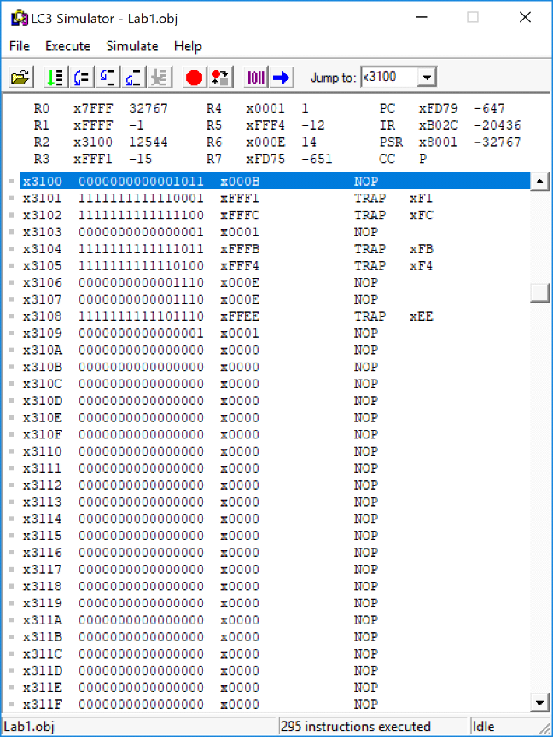

(X,Y) Pair (-11,15)

(X,Y) Pair (-15,11)

